Help support our school, whilst supplying chocolate-free gifts
and gardening ideas to parents, family and friends!

EVERLASTINGS ARE:
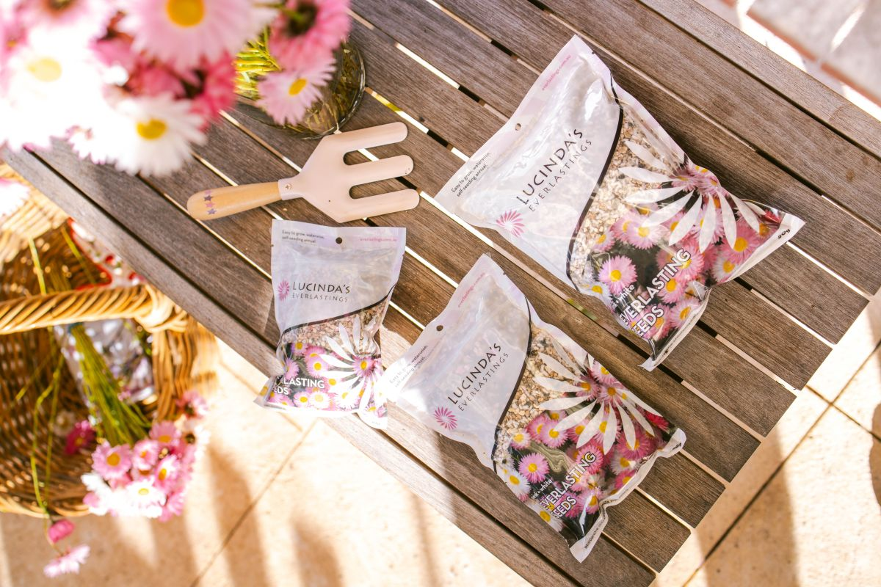
- Water-wise
- Bold and beautiful
- Easy to grow with 100% germination
- Australian native, not an environmental weed
- Long flowering from July to November
- Self-seeding annuals, requiring little maintenance
- Long lasting seed, viable for at least 10 years

USED FOR:
- Garden beds
- Driveways
- Pot plants
- Road verges
- Cut or dried flowers
- A special gift or souvenir
- Flowers for a vase

ORDER FORM
Packets of everlastings available in three sizes. A 10g packet of everlasting seed will cover an area of 10m² in your garden! The seed has 100% germination, and will last for 10 years after purchase.
For growing instructions see www.everlastings.com.au.
NAME |  |  |  | CLASS |  |  | TEACHER
Pack Size |  |  | Price |  |  | Quantity |  |  | Total Cost
10g everlasting packets |  |  | $10
20g everlasting packets |  |  | $20
50g everlasting packets |  |  | $40
 |  |  |  |  |  | TOTAL |  |  | $

Please enclose money with this form and return to your school by _______________________________ .
Remember: 50% of the purchase price goes directly to your school!

